Winscore 2025 Rev 6 Release Notes

June 10, 2025

**Introduction:**

The main effort in this release is to automate the requirement for pre contest motor runs for motorgliders. Also, much effort was made to increase the reliability of engine run detection when a flight is analyzed.

**Highlights of the release**:

The Automatic Scoring now has a feature to download flight logs received for 14 days prior to the first contest day. No task is required, nor should any “dummy tasks” be created. The official practice days are not included in this option, those must be processed as before.

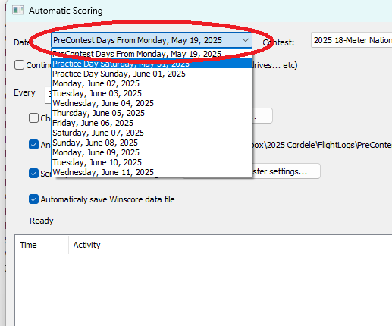

Logs which are downloaded via the pre contest option above, will appear in the new customized flight log display:

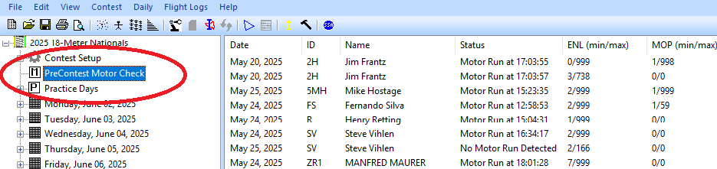

The columns in this display show information relevant to their engine run.

When an engine run is detected, then a baseline for that recorder is saved in Winscore. Those baselines can be seen in the contest setup area:

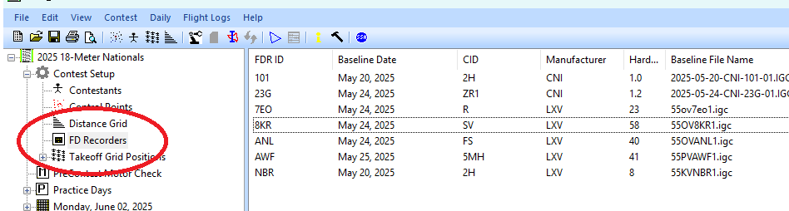

Since the baseline information was determined from a log with an actual engine run, then the ENL and MOP values for that recorder are used in subsequent contest flights to improve the accuracy of engine detection.

Note there can be more than one recorder entries for the same contestant because a given contestant may submit logs from one or more recorders as part of the pre contest submission.

The contestant list now shows the latest flight recorder ID submitted by the pilot. From this it should be easy to see which pilots have submitted an engine run log, and which haven’t.

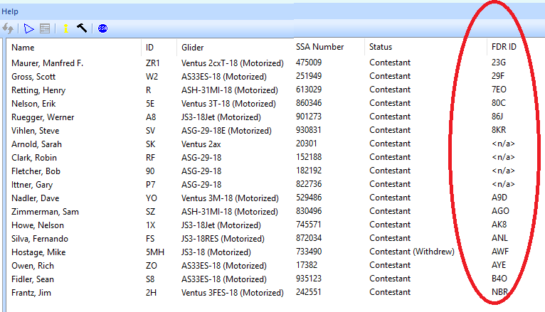

Note the <n/a> indicates a non-motorized glider has been registered.

The first log with an engine run detected is assigned to the contest. If the scorer has determined that a log contains a valid engine run, he may manually assign that log to the baseline recorder list and the contestant with the following right menu option:

